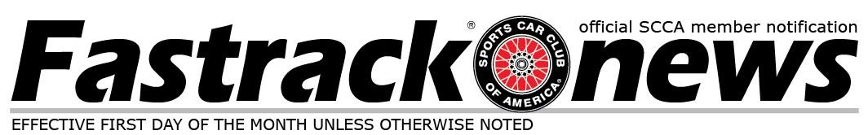

TTB Meeting Minutes – January 18, 2022
The TTB met via zoom: Present were Staff members John Hunter and Justin Barbry, BoD liaisons Clay Turner and Charlie Davis, and members at large Doug Wille, Gregg Ginsburg, Brian Kuehl, and Bob Tunnell. Also present were Kathy Barnes and Ryan Cheek.

Member Advisories
The Time Trials National Tour has updated its cancellation policy for 2023.
“Full refund will be provided for cancellations requested 2 weeks before the event. Cancellation requests must be submitted through "My Events" on your Member Account Profile - find your event and click the "cancel" button. For cancellations made within 2 weeks of the event, a $100 cancellation fee will be applied to Time Trials National Tour registrations and a $50 cancellation fee will be applied to Track Event registrations.”

Sanctioning Process
The process to sanction an event has been updated for 2023. While we still heavily recommend having an Event/Registration page up at the time of the sanction request (so that the URL submitted can properly update the Find Your Fun and Find Events on both the SCCA and Time Trials websites) we will once again be accepting Supps and Schedules as the base for sanction. Please visit the Sanction Requirements under the Admin Procedures tab on the Time Trials website for details.

Part Approval Requests:

Approved:

Sport Category
- Storm Lowering Springs for Hyundai Kona N – the TTB feels that these do meet the criteria and intent for allowed lowering springs and so they have been added to the alternate approved lowering springs list.

- Forge Motorsport Induction Kit for Hyundai i30N, Kona N, Veloster N, and Elantra N. Part number: FMINDK28 – the TTB feels that this does meet the criteria and intent for allowed air intakes.

- Mazda RX8 sway bars on NC Mazda Mx-5’s – the TTB feels that these do meet the criteria and intent for allowed sway bars and so they have been added to the alternate approved sway bar list.

- Hotchkis Sport Swaybar Kit - F22 / F30 / F32 Car Set. Part number: 22841 – the TTB feels that these do meet the criteria and intent for allowed sway bars and so they have been added to the alternate approved sway bar list.

- F22/ F30/ F32 RWD Dinan Adjustable Sway Bar Set. Part number: D1200585 – the TTB feels that these do meet the criteria and intent for allowed sway bars and so they have been added to the alternate approved sway bar list.

- RS-R TOYOTA GR86 2022+ SUPER DOWN SPRINGS. Part number: T067S
– the TTB feels that these do meet the criteria and intent for allowed lowering springs and so they have been added to the alternate approved lowering springs list.

- Perrin Performance - 19mm or 22mm Front Sway Bar - Subaru BRZ / Scion FR-S / Toyota GT86. Part number: PSP-SUS-13 – the TTB feels that these do meet the criteria and intent for allowed sway bars and so they have been added to the alternate approved sway bar list.

- Perrin Performance -16mm Rear Sway Bar - BRZ/FR-S/86/GR86. Part number: PSP-SUS-229 – the TTB feels that these do meet the criteria and intent for allowed sway bars and so they have been added to the alternate approved sway bar list.

Not Approved:

Sport Category
• Moroso Road Race Oil Pan: The TTB received a request to allow the use of this baffled oil pan in Sport as a “common reliability bolt on”.
The TTB feels this modification, when applied to all cars, does not align with the Sport Category philosophy of “in the driveway with hand tools”.

Tuner Category
• DG Motorsports hardtop. The TTB received a request to allow the use of the DG Motorsports hardtop for the ND (2016-2023) MX-5 in Tuner.
The TTB does not feel that allowing aftermarket hardtops, when there wasn’t an OE option, fits the overall ethos of the Tuner Category at this time.

Technical Bulletins
There are no items out for comment at this time

For Member Comment:
There are no items out for comment at this time

Class Changes
There are no proposed class changes at this time

Rules Changes

There are no proposed rule changes at this time

Classed Cars
• No cars for this Fastrack, but there are cars in the que that will be classed before the VIR event.

